**Monton, Sean Paul M.**

**BSCS 1-1**

**Computer Programming 1 – Activity 10 (Temperature Conversion)**

**Output**

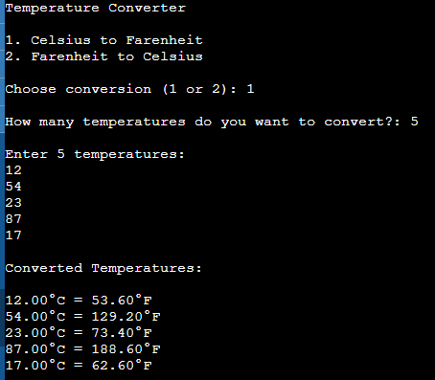

**Source Code**

#include <stdio.h>

#include <stdlib.h>

int main() {

int choice = 0, num;

printf("Temperature Converter\n\n");

printf("1. Celsius to Farenheit\n");

printf("2. Farenheit to Celsius\n");

while (choice != 1 && choice != 2) {

printf("\nChoose conversion (1 or 2): ");

scanf("%d", &choice);

if(choice != 1 && choice != 2) {

printf("\nInvalid Choice, Please input 1 or 2");

}

}

printf("\nHow many temperatures do you want to convert?: ");

scanf("%d", &num);

printf("\nEnter %d temperatures:\n", num);

float temperatures[num];

for(int i = 0; i < num; i++){

scanf(" %f", &temperatures[i]);

}

printf("\nConverted Temperatures:\n");

float convertedTemperatures[sizeof(temperatures) / sizeof(temperatures[0])];

for(int i = 0; i < num; i++) {

if(choice == 1)

convertedTemperatures[i] = (1.8 * temperatures[i]) + 32;

else

convertedTemperatures[i] = 0.56 * (temperatures[i] - 32);

}

for(int i = 0; i < num; i++){

if(choice == 1)

printf("\n%.2f°C = %.2f°F", temperatures[i], convertedTemperatures[i]);

else

printf("\n%.2f°F = %.2f°C", temperatures[i], convertedTemperatures[i]);

}

return 0;

}